# Meeting 29/09:

Attendance:

Luke

Faith

Orson

Kate

Emeka

Kostiantyn

Domain:

4. Fast Food delivery service, e.g. deliveroo

Presentation:

Ethics Canvas

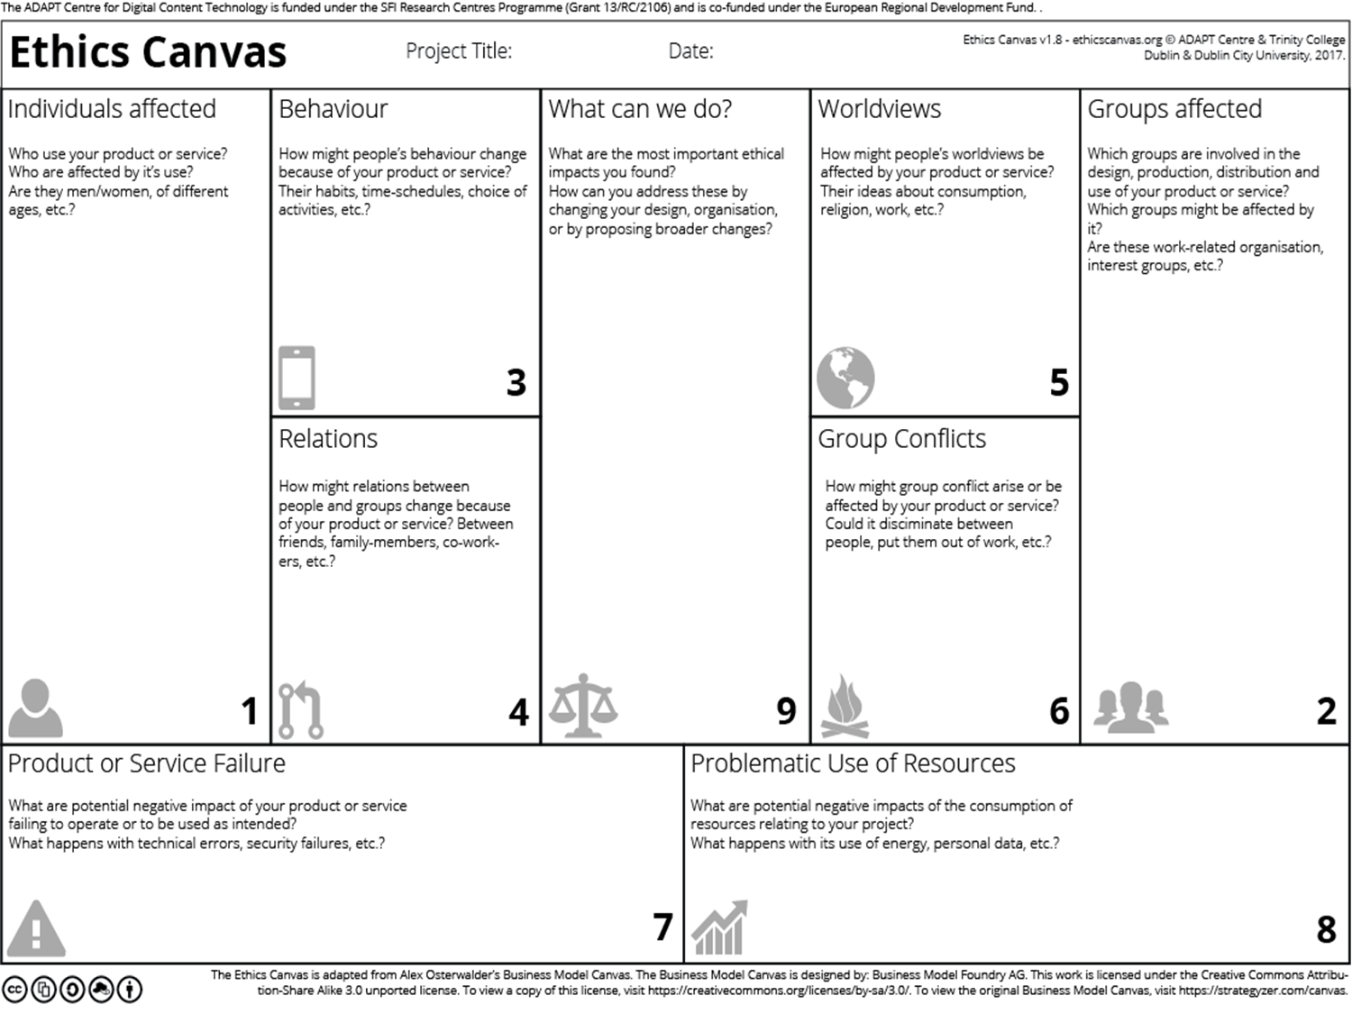

# Key Points for Presentation:

* 7 - 10 minutes long
* We will be presenting the first iteration of ethics canvas (first version)
* Overview describing the system we are designing
* Description of how we created the diagram (backgrounf research and drawing tool used)
* Explain purpose of diagram
* Explain why we are focusing on this diagram (ethics canvas)
* Draw attention to some interesting aspects of the diagram
* Explain what next stsps are for the remainder of the assignment time and what we could do if we had more time
* Explain strengths and weaknesses of the aspect of the design

Consider

* How the diagram was created
* Whether ethical considerations have been included yet
* Validation of diagram with users
* Scope of research – local, national, international
* Terminology used
* The number of perspectives considered
* Supporting documentation for the diagram or the domain.

# 

# Tasks to Prep for Part 1 Of Assignment Sheet:

1. Research takeaway service
2. Start thinking about possible ethical considerations
3. Start thinking about possible use cases (ovals) for our system also thing about how this use case would operate normally and how it would operate in an error scenario (We need 8 of these)

* What are UML
* Use Case Diagrams used for?
* List some advantages of using use case diagrams and supporting tables and descriptions.
* Ask these questions for eahc of the UML diagrams

1. Think of possible classes for class diagram (We need 15 classes with 2 attributes in 1 diagram, for example class: Employee and attributes could be int: employeeId and String: employeeName)
2. Think about activity diagram for two specific use cases form point 3
3. List of who did what
4. Discussion of overall strengths and weaknesses of overall design

# Class 3/10:

# Parts: PART 1 UML (Assignment Sheet)

Due 21/10

Aim to have it done on time lol

NB: I highly recommend keeping a note of what you do as part of the project from now so when it comes to writing the report you’re not struggling to remember what you did

1. Everyone
2. Everyone
3. Faith (done)& Luke
4. Kate & Kost
5. Emeka & Orson
6. Everyone (report)
7. Everyone

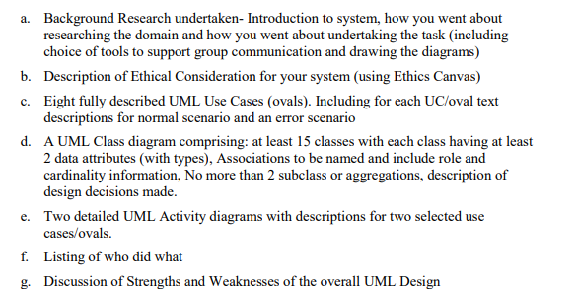

# Parts: Presentation of Ethics Canvas

Due 14/10

Aim to have this done by the end of this week so we can then record the presentation, combine them and submit by Sunday this week so we have all of next week to work on Part 1

1. Emeka (done)
2. Luke(done)
3. Emeka(done)
4. Orson(done)
5. Faith(done)
6. Faith(done)
7. Orson(done)
8. Kost (done)
9. Kate (done)

